**Market Report**

Drop Calf Sale. Saturday 21st January

***Top Price on the day was Lot 625 @ £310 for Aberdeen Angus Heifer calf (137kg) for Clough Farmer.***

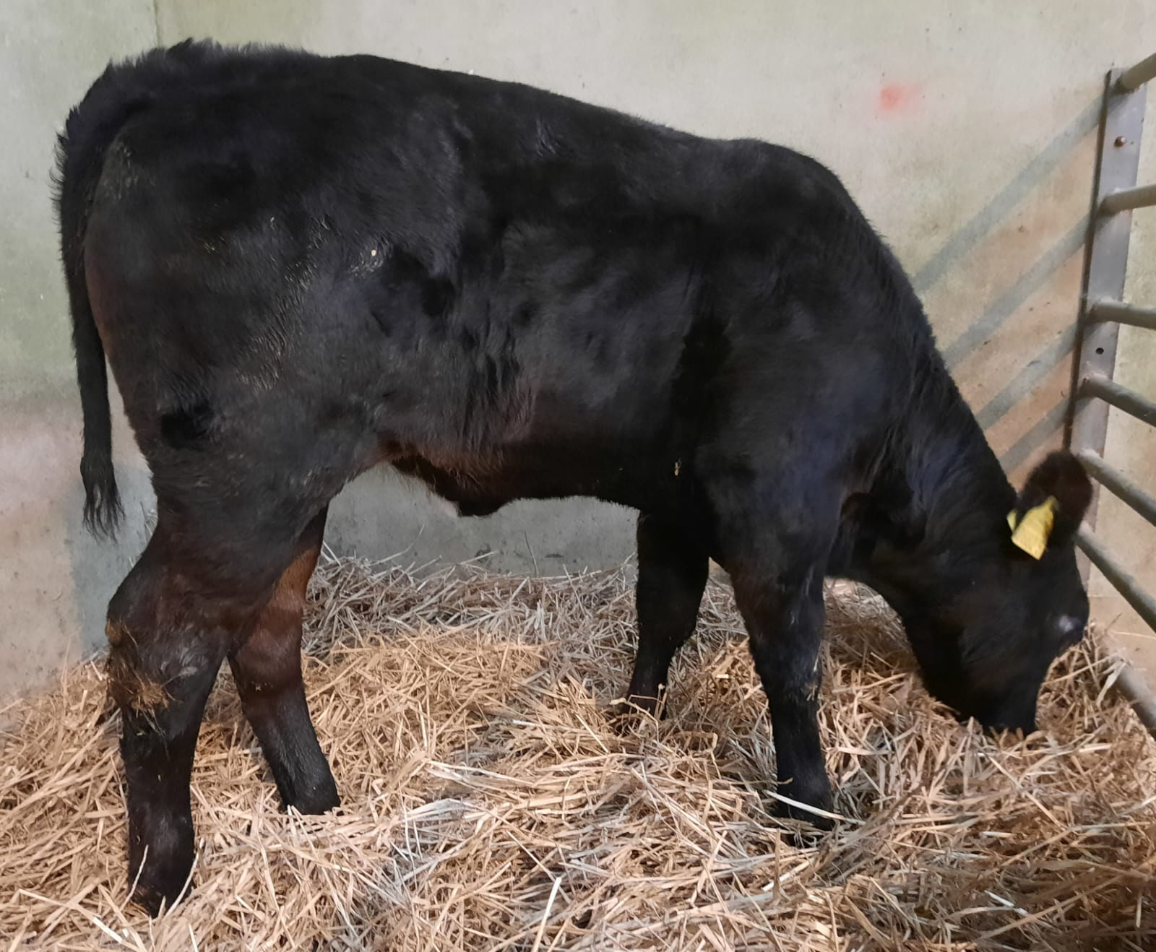

Top 10 Males :

AA (82kg) £300 for Portaferry Farmer, AA (89kg) £270 for Clough farmer, BB (65kg) £270 for Lisbane Farmer, BB (81kg) £250 for Portaferry Farmer.

AA (75kg) £240, BB (57kg) £215, AA (66kg) £195, BB (66kg) £195, AA (64kg) £190 for Lisbane Farmer. AA (60kg) £170 for Crossgar Farmer.

Top 10 Females:

AA (137kg) £310 for Clough Farmer,

BB (67kg) £260, BB(70kg) £240, BB (66kg) £200 for Lisbane Farmer.

AA (89kg) £180 for Crossgar Farmer, AA (70kg)£155 for Clough Farmer.

AA (85kg) £150, BB (79kg) £140, BB (87kg) £135 for Portaferry Farmer.

AA (79kg) £130 for Clough Farmer